**Ben Ghirardani PDA**

**Unit Implementation & Testing**

I & T 5 - Demonstrate the use of an array in a program

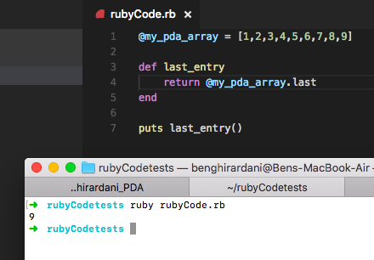

The result of calling the “last_entry” method is 9, as can above.

I & T 6 - Demonstrate the use of a hash in a program

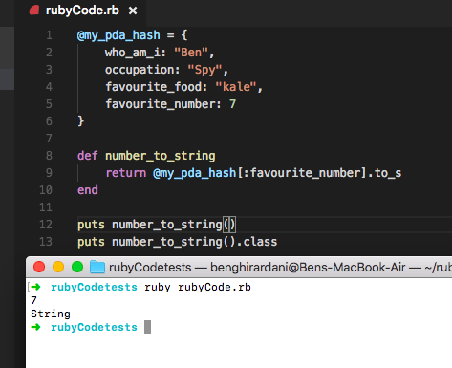

The result of calling “number_to_string” is 7 expressed as a string, as seen above.

I & T 3 - Demonstrate searching data in a program

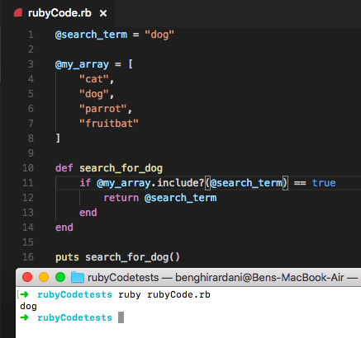

The result of calling “search_for_dog” on “my_array” is dog, as “search_for_dog” has searched through the array and determined that “dog: does appear in the array.

I & T 4 - Demonstrate sorting data in a program

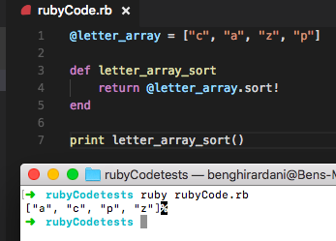

The result of calling “letter_array_sort” can be seen above as [“a”, “c”, “p”, “z”]

I & T 7 - Demonstrate the use of Polymorphism in a program

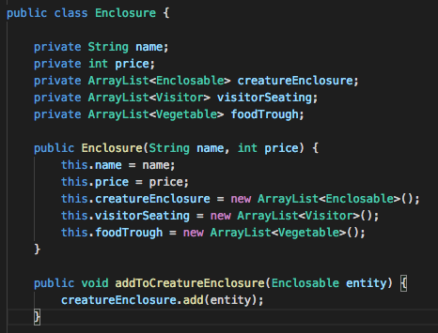

The class above shows an arraylist named “creatureEnclosure” that takes in instances of “Enclosable”, as well a method to add instances of “Enclosable” to the arraylist.

The screengrab below shows the “Enclosable” class.

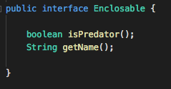

The screengrab below shows that the class “Creature” implements “Enclosable”.

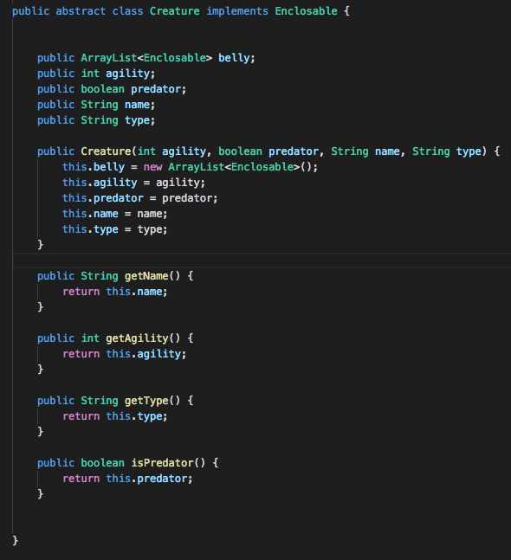

The following two screengrabs show that the classes “Dragon” and “Unicorn” implement the class “Creature”. Therefore, the arraylist named “creatureEnclosure” can take in instances of “Dragon” and “Unicorn”.

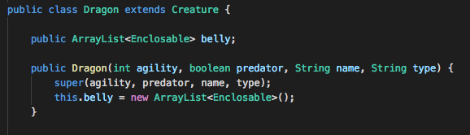

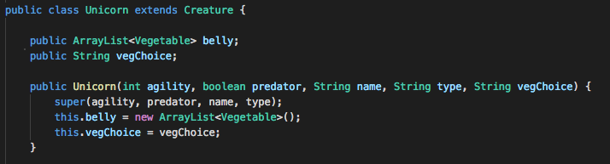

The following method casts an instance of the Dragon class from the Enclosable class which the creatureEnclosure takes in.

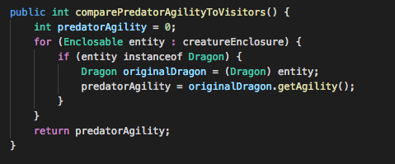

I & T 1 - Take a screenshot of an example of encapsulation

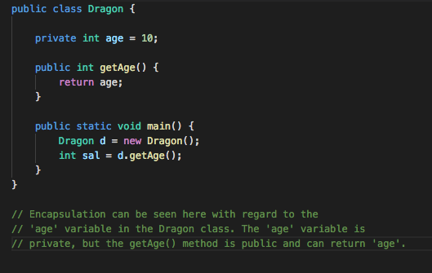

I & T 2 - Take a screenshot of the use of inheritance in a program

Take screenshots of:

A Class:

A Class that inherits from the previous class:

An object in the inherited class:

A method that that uses the information inherited from another class:

